**Opinion Analyzer for A Templated Streaming Services Application**

**Table of the content**

|  |  |  |  |
| --- | --- | --- | --- |
| **S.NO** | **TITLE** | | **Page no** |
|  | **ABSTRACT** | |  |
|  | **LIST OF FIGURES** | |  |
| 1 | **INTRODUCTION** | |  |
|  | 1.1 | Existing System |  |
|  | 1.2 | Proposed System |  |
| 2 | **PROJECT DESCRIPTION** | |  |
|  | 2.1 | Project Description |  |
| 3 | **SYSTEM DESIGN** | |  |
|  | 3.1 | System Architecture |  |
|  | 3.2 | Data Flow Diagram |  |
|  | 3.3 | Sequence Diagram |  |
|  | 3.4 | Use Case Diagram |  |
| 4 |  | **SYSTEM CONFIGURATION** |  |
|  | 4.1 | Hardware Requirement |  |
|  | 4.2 | Software Requirement |  |
| 5 | **SOFTWARE SPECIFICATION** | |  |
|  | 5.1 | About the Frontend |  |
| 6 | **IMPLEMENTATION RESULTS** | |  |
|  | 6.1 | Development Approach |  |
|  | 6.2 | Testing |  |
| 7 | **CONCLUSION AND FUTURE ENHANCEMENT** | |  |
|  | **APPENDIX** | |  |
|  | A | Source Code |  |
|  | B | Screen Shots |  |
| 8 | **BIBLIOGRAPHY** | |  |

**ABSTRACT**

Mental health is considered as one of the most sensitive topics of research

and it is highly affected by an individual’s mood and sentiments. Social media has

been proven to be one of the major catalysts in deterioration and ﬁckleness of one’s

mind. In this paper, we present an android application called “moody buddy” ingra-

tiated with a heartbeat analyzing hardware kit which would detect and analyze the

moods and emotions of an individual very close to accuracy. Mood recognition and

sentiment analysis is a vast and complex area of research. Moreover, monitoring

human emotions is found out to be one of the technically challenging aspects. So, in

order to achieve the quality output of our research and testing work, we have taken

help from artiﬁcial intelligence and Internet of Things domain. Here, we have con-

sidered the activity of the user on his/her social networking as a starting point of our

research work. The concept of logistic regression is used in our software. In order to

solidify our idea more, we are adding a hardware component which would monitor

the heartbeat of the person and its modulation. In case of any abnormality examined

in the heart rate, the questionnaire appears again. At the end, a cumulative of the

hardware component’s results and software component’s would help us analyze and

detect the current mood of the individual to very close to high accuracy value.

Mental health is considered as one of the most sensitive topics of research and it is highly affected by an individual’s mood and sentiments. Social media has been proven to be one of the major catalysts in deterioration and ﬁckleness of one’s mind.

In this project, we present an android application called “moody buddy” ingratiated with a heartbeat analyzing hardware kit which would detect and analyze the moods and emotions of an individual very close to accuracy. Mood recognition and sentiment analysis is a vast and complex area of research. Moreover, monitoring human emotions is found out to be one of the technically challenging aspects. So, in order to achieve the quality output of our research and testing work, we have taken help from artiﬁcial intelligence and Internet of Things domain. Here, we have considered the activity of the user on his/her social networking as a starting point of our research work. The concept of logistic regression is used in our software. In order to solidify our idea more, we are adding a hardware component which would monitor the heartbeat of the person and its modulation. In case of any abnormality examined in the heart rate, the questionnaire appears again. At the end, a cumulative of the hardware component’s results and software component’s would help us analyze and detect the current mood of the individual to very close to high accuracy value.

**1.INTRODUCTION**

Mental health mobile applications are, nowadays, very common; and the fact that they have become more common has a positive impact on mental health in general because it brings a “reduction of stigma associated with seeking mental health treatment”. However, most are not supported by professionals in the field, and more rigorous research and design guidelines for the functionalities and interfaces of mental health mobile applications available for smartphones are needed.

A lot of these applications have their approach centered around the use of mood trackers, which are defined by Caldeira as “an approach to help healthy individuals stay in healthy emotional states, and assist individuals with mental diseases” by registering moods and emotions in a timeframe. Mood trackers help people get a better overview of their emotional state, by learning about their mood patterns and reflecting on them, which helps manage emotional distress. Mood differs from emotions – which are short-lived reactions to stimuli –, and can be defined as “a mild, diffuse, pervasive feeling state that is experienced as pleasant or unpleasant, and which has a broad influence on perceptions, motivation, and behavior”.

Mood is interesting to study and to record in the context of mental health because it “has a direct influence on people’s subjective well-being,” i.e., their happiness. An example of a mood tracker used by soldiers is a mobile application that enables users to rate their moods, to self-monitor across time, and to report their emotional experiences to health providers, with the purpose of tracking and preventing symptoms associated with deployment-related behavioral health issues, including post traumatic stress disorder, head injury, stress, depression, anxiety, and general well-being . Currently the market is overflowing with mood tracker applications; one quick search using the keywords “mental health” or “mood tracker” in any application store will lead us to a numerous amount of options to choose from. However, most of these are not specifically designed for individuals that suffer from mental illness or people who currently go to therapy, rather focusing on the general population. As a consequence, the current widespread mood trackers seem limited in several, especially for an audience dealing with mental illness. These limitations may be linked to the lack of 1 user experience research, as well as GUI (graphical user interface) research in interactive applications in the medical field. In this paper we begin by discussing what mood trackers are used for.

Subsequently we define the analysis criteria, and present the analysis of various examples, drawing conclusions about the potential role of Interaction Design in improving this type of product, and finally we make suggestions for future studies regarding the topics in question.

**Mood Tracking**

Mood tracking is the act of registering through a period of time the mood one feels and how day to day life can affect mood; many times to try to find patterns within routines that can be either helpful or harmful towards overall wellbeing and mental health. This act of tracking one’s mood has shown to be helpful when it comes to health management . There are several tracking mobile applications in the market, from focusing on tracking the amount of water the user drinks per day, to how many cigarettes they smoke. These habit-tracking apps seem to always be connected to the users wanting/needing help to accomplish a positive change in their life.

Mood trackers have some variances as well, from merely allowing the user to input their current mood, to associating the current mood with an event, people, or daily habits, such as exercising. Mood trackers can be significantly improved by an Interaction Design intervention. For example, a user experience study and analysis of what users need and expect from mood trackers can provide designers with valuable insight that will allow them to better tend to the users’ needs. Furthermore, involving therapists in the process of creating mood trackers can also provide a better understanding of what their clients’ needs are.

This study analyses several of the most popular mood trackers currently in mobile applications stores. The criteria for choosing these mood trackers were both the order that they appeared when conducting a search in both Google Play Store and Apple Store, and their ratings according to users. This paper reports a first introductory analysis using some of the criteria we found important to implement in a future co-designed application with a therapist

* 1. **Existing System**

1. To decrease the rate of depression: One of the biggest pros of this invention would
2. be an improvement in the mental health of the country. India ranks ﬁrst in terms of
3. most depressed countries. So, it is a prime time for some development to be done
4. at this particular arena.
5. •To manifest a wholesome solution to the respective moods detected by the software:
6. For an instance, if the person is feeling low or sad (according to the calculated
7. results), timeline from Facebook full of vivid colorful memories would pop up on
8. the screen or suggestion of the users favorite song might also pop up as a suggestion.
9. Different actions are taken according to the current mood of the person. Similar
10. ways if the person is angry or in a hyperactive situation, motivational quotes would
11. pop up or motivational videos will start playing automatically.
12. •To invent a breakthrough technology in the ﬁeld of mental health care: Talking
13. about mental health, not much has been contributed by the ﬁeld of technologies

To decrease the rate of depression: One of the biggest pros of this invention would

be an improvement in the mental health of the country. India ranks ﬁrst in terms of

most depressed countries. So, it is a prime time for some development to be done

at this particular arena.

•To manifest a wholesome solution to the respective moods detected by the software:

For an instance, if the person is feeling low or sad (according to the calculated

results), timeline from Facebook full of vivid colorful memories would pop up on

the screen or suggestion of the users favorite song might also pop up as a suggestion.

Different actions are taken according to the current mood of the person. Similar

ways if the person is angry or in a hyperactive situation, motivational quotes would

pop up or motivational videos will start playing automatically.

•To invent a breakthrough technology in the ﬁeld of mental health care: Talking

about mental health, not much has been contributed by the ﬁeld of technologies

To decrease the rate of depression: One of the biggest pros of this invention would

be an improvement in the mental health of the country. India ranks ﬁrst in terms of

most depressed countries. So, it is a prime time for some development to be done

at this particular arena.

To manifest a wholesome solution to the respective moods detected by the software:

For an instance, if the person is feeling low or sad (according to the calculated results),

To invent a breakthrough technology in the ﬁeld of mental health care: Talking

about mental health, not much has been contributed by the ﬁeld of technologies.

**1.2 Proposal System**

Technological change invades most areas of society and many different aspects of our lives. The utilization of technologies, such as the Internet, increased across all sectors of society. Digital devices and applications play key roles in our daily life and in a wider range of the society. This gives us insight to develop a system, which can contribute to the inclusion of different people in digital world. The proposed system is an example of public participation in society.

Three local newspapers suggested the incentive. The goal was to implicate public participation through comments of newspapers’ news about the written texts in order to get more ideas about how to address the narratives. Conversely, they wanted to get data about a subject and then, inform others about people’s opinions.

The main purpose of this project is to present the analyses of the principal techniques of feelings detection in a population, to verify the viability of the development of a system prototype that allows to withdraw people’s opinions about different themes. Comments are extracted from online newspapers expressing feelings related to the news. During this work’s development some issues emerged, such as, the way to extract newspapers comments and how it would be analyzed.

**2 PROJECT DESCRIPTION**

From an interaction design perspective, mood tracker applications vary greatly from applications like T2 Mood Tracker – whose interface is somewhat outdated and narrow, allowing exclusively one thing: tracking moods (only the several moods it has predefined, never just one or two), and it does not do it very well from an user experience standpoint –, to applications such as Youper - which tries to bring innovation into the mobile mental health world through artificial intelligence, in a chat format, to possibly try and establish rapport with the user.

One big contribution Interaction Design can make towards a better designed mood tracker starts with research. Cooper [9] begins his interaction design process with research, by comparing types of research (quantitative versus qualitative), and introduces the reader to “goal-directed design.” Another good contribution interaction design can have is the fact that most mood trackers are made for mobile graphic interfaces, which can be a very helpful medium to carry daily use interfaces, however designing something for a smartphone screen is very different from designing a web browser or a computer application.

Interaction design approach to the analysis. Our research focused on authors who had previously defined rules for graphic user interfaces and mobile applications. These criteria are adapted to mobile. The first criteria we chose to analyse was the target audience/stakeholder for each application, since previous studies have shown that some applications in the market are aimed at a general public and not people undergoing therapy. However the constant change in the market compelled us to maintain this criteria. The second one, was the input of emotions, focusing on whether it would allow for only one emotion or multiple emotions at the same time. Humans are complex beings, and it is often very difficult to translate all that we are feeling into one word or emotion. Furthermore, mood can consist of several emotions. In terms of interaction design, we analysed the interaction types , which could be classified as instructing, conversing, manipulating, exploring, or responding. Instructing is defined as the user giving input to a system, which can range from typing in commands into a command line to speaking commands aloud. Secondly, conversing proposes a dialog between user and system. Manipulating requires the users to apply their knowledge of the world around them to the interface in question, either virtual or physical. Lastly, responding is defined as the system starting the conversation with the user and the user being able to choose whether or not to respond to it. We further analysed interaction styles. Shneiderman separates these interaction styles into five main categories: direct manipulation , menu selection, form fill-in, command language, and natural language . Direct manipulation is defined as simplifying the user’s tasks in a familiar way or concept so that it is easier to understand for the user. The author provides examples such as the desktop metaphor and drawing tools in software. Navigation and menu selection, as the name suggests, focus on the use of menus for navigating the software. This interaction style provides users with an easily accomplished task “with little learning or memorization in just a few actions” . Form fill-in is a common type of data entry, commonly used in registration forms for fields such as date of birth and country, it is usually pre-filled and requires only simple selection from the user. The previous three interaction styles were the only ones observed in the mood tracker applications. Command language requires a more frequent user and provides users with a strong feeling of being in control (e.g., programming) and natural language, although used in a lot of mobile phones nowadays, has not really been transferred over to a lot of mobile applications. Natural language can be anything from text-to-speech, to the user being allowed to give commands just by speaking (e.g., Siri, Alexa).

**Emotion mood in Analyzer**

In this paper the author presents a comparison between some publications with different methods of emotion detection, making the distinction between the accuracy of each method, the granularity of mood taxonomies used and some possible applications. It starts by giving a brief view over some audio features in music that were used in the analyzed papers, organizing them into eight distinct groups:

* Musical surface (or timbre texture) composed with features mostly based on the Short-Time Fourier Transformation (STFT). Some of those features are: centroid, roll off, spectral flux, zero crossings and low energy / average silence ratio.
* Spectral Flatness Measure (also called tonality coefficient).
* Spectral Crest Factor.
* Mel Frequency Cepstral Coefficients (MFCC) (often used in speech recognition).
* Daubechies Wavelet Coefficient Histogram (DWCH).
* Beat and tempo detection.
* Genre information, which tends to be expensive, needing to be handcrafted in songs or pooled from internet. It is also prone to errors.

To continue this project and be able to get an input in order to be analyzed by SentiStrength, several components had to be drawn up as a Web Spider and a filter. Both components were performed using the Python scripting language considering that it is easier to implement, and it has a library called Beautiful Soup, which has functions that allow to extract archive data HTML.

**Web Spider**

A Web Spider is a computer program that browses by the World Wide Web in a methodical and automated way. For the development applications of the web spider several frameworks can be used and one of them is the Scrapy. It is an open source framework implemented in Python which provides components for the selection and extraction of data from sources as HTML and XML. This component was developed to withdraw specific informations of the HTML’s components of a particular site, in that case, online newspapers sites. The comments are extracted depending on the date and topic entered by users in order to simplify the research and therefore the information to extract. In such a way to remove the comments according to the conditions imposed by the user, the web spider will compare the introduced dates with every news date; if it is within the range it shall be checked in the title of itself, if it finds the topic introduced by the user. In case all these requirements occur, the comments will be removed and stored in a text file. The web spider removes the comments through the HTML tags presented in each site and, each of them has different tags. The negative point is that it needs to make different web spiders for different newspapers. In some newspapers the comment section is a Facebook plug-in, this make the withdrawal of the comments harder because the plug-in redirects to another HTML page. So, in this project we do not remove the comments from the newspapers that have this section. In the future we will sort this problem.

**Filter**

There is a large amount of repeated information and the SentiStrength only evaluates texts written in one line. It was decided to carry out a filter where all the repeated information’s, line breaks and enters are eliminated to get an evaluation more concise of the matter. Keeping the file initial order resulting from the web spider, the filter begins by withdrawing the repeated comments and then removes the characters “\n” and “\r” so the comments are all kept in just one line and be considered by the SentiStrength as one only text.

**Tests**

After the comments extracted using the web spider and filter we can initiate the comments analysis by algorithms. The algorithms we found available to perform the tests were the SentiStrength and the LIWC. Though the LIWC full version is paid, we can find it online with a limited characters version (5000). Therefore, we shaved the sample to allow the analysis using the two algorithms. SentiStrength: Coursing through a set of comments, a meaning according to these is withdrawn through the words, which composed it. It was verified that if each one of these words were in the dictionary they were classified according to their value, negative or positive. Finally, values of each presented word in each comment were summed up, which reflected an average of the positive and negative values of the comment. Through these values it was possible to say if the comment contained a positive or negative emotion. LIWC: In the version that is available on LIWC site only English language texts are analyzed. We can also verify that LIWC has several options to classify the texts that we wish to analyze, such as personal writing, social network, scientific writing among others.

**Interface**

The user can take advantage of the components mentioned earlier through a developed web application. Some of the application’s storyboards are in next figures. The user chooses the comments that they want to extract from newspapers. To have a personalized search, they can only choose one newspaper or choose several. After choosing the newspapers, the user chooses the time interval from which comments will be taken. The search can be more detailed if the user searches directly the event they want. In this case, comments are extracted depending on the topic that the user introduced.

**3.SYSTEM DESIGN**

**3.1 System Architecture**

**Python**

The system architecture diagram is an abstract depiction of the system’s component architecture. It provides a succinct description of the system’s component architecture in order to assist in component-component relationships and system functioning.

The system architecture diagram is a visual representation of the system architecture. It shows the connections between the various components of the system and indicates what functions each component performs. The general system representation shows the major functions of the system and the relationships between the various system components.

**Python:**

Python is an interpreted, object-oriented, high-level programming language with dynamic semantics. Its high-level built in data structures, combined with dynamic typing and dynamic binding, make it very attractive for Rapid Application Development, as well as for use as a scripting or glue language to connect existing components together.

Python's simple, easy to learn syntax emphasizes readability and therefore reduces the cost of program maintenance.

Often, programmers fall in love with Python because of the increased productivity it provides. Since there is no compilation step, the edit-test-debug cycle is incredibly fast. Debugging Python programs is easy: a bug or bad input will never cause a segmentation fault. Instead, when the interpreter discovers an error, it raises an exception.

When the program doesn't catch the exception, the interpreter prints a stack trace. A source level debugger allows inspection of local and global variables, evaluation of arbitrary expressions, setting breakpoints, stepping through the code a line at a time, and so on.

The debugger is written in Python itself, testifying to Python's introspective power. On the other hand, often the quickest way to debug a program is to add a few print statements to the source: the fast edit-test-debug cycle makes this simple approach very effective.

Python is often compared to other interpreted languages such as Java, JavaScript, Perl, or Smalltalk. Comparisons to C++, Common Lisp and Scheme can also be enlightening. In this section I will briefly compare Python to each of these languages.

These comparisons concentrate on language issues only. In practice, the choice of a programming language is often dictated by other real-world constraints such as cost, availability, training, and prior investment, or even emotional attachment. Since these aspects are highly variable, it seems a waste of time to consider them much for this comparison.

**Machine Learning:**

Machine learning (ML) is an AI technique that uses mathematical algorithms to create predictive models. An algorithm is used to parse data fields and to "learn" from that data by using patterns found within it to generate models. Those models are then used to make informed predictions or decisions about new data.

**Machine Learning**is the ability of the computer to learn without being explicitly programmed. In layman’s terms, it can be described as automating the learning process of computers based on their experiences without any human assistance.

Machine learning is actively used in our daily life and perhaps in more places than one would expect.

**Machine Learning** is a system of computer algorithms that can learn from examples through self-improvement without being explicitly coded by a programmer.

Machine learning is a part of artificial intelligence which combines data with statistical tools to predict an output that can be used to make actionable insights.

The breakthrough comes with the idea that a machine can singularly learn from the data to produce accurate results.

Machine learning is closely related to data mining and Bayesian predictive modeling. The machine receives data as input and uses an algorithm to formulate answers.

A typical machine learning tasks are to provide a recommendation. For those who have a Netflix account, all recommendations of movies or series are based on the user’s historical data. Tech companies are using unsupervised learning to improve the user experience with personalizing recommendations.

Machine learning is also used for a variety of tasks like fraud detection, predictive maintenance, portfolio optimization, automated task, and so on.

**Deep Learning:**

Deep learning can be considered as a subset of [machine learning](https://www.simplilearn.com/tutorials/machine-learning-tutorial/what-is-machine-learning). It is a field that is based on learning and improving on its own by examining computer algorithms.

While machine learning uses simpler concepts, deep learning works with artificial neural networks, which are designed to imitate how humans think and learn.

Until recently, [neural networks](https://www.simplilearn.com/tutorials/deep-learning-tutorial/what-is-neural-network) were limited by computing power and thus were limited in complexity.

However, advancements in [Big Data analytics](https://www.simplilearn.com/what-is-big-data-analytics-article) have permitted larger, sophisticated neural networks, allowing computers to observe, learn, and react to complex situations faster than humans.

Deep learning has aided[image classification](https://www.simplilearn.com/tutorials/deep-learning-tutorial/guide-to-building-powerful-keras-image-classification-models), language translation, speech recognition. It can be used to solve any pattern recognition problem and without human intervention.

Deep learning systems require large amounts of data to return accurate results; accordingly, information is fed as huge data sets.

When processing the data artificial neural networks are able to classify data with the answers received from a series of binary true or false questions involving highly complex mathematical calculations.

**AI Architecture:**

AI architects work in the field of information technology to develop and implement infrastructure for applications, databases, and computer networks. When it comes to governing and scaling AI efforts, they serve as the connecting tissue between [data analysts](https://www.simplilearn.com/what-does-a-data-analyst-do-article), database administrators, [programmers](https://www.simplilearn.com/how-to-become-programmer-article), operators (DevOps, Data Ops, ML Ops), and business unit executives.

**Artificial intelligence will smartly enable architecture to open the gates to smart homes; that are complex living & data-driven spaces. Parametric, kinetic design and complex volumes that are extremely efficient and not just cubes / cuboids will be the new normal.**

**3.2 Data Flow Diagram**

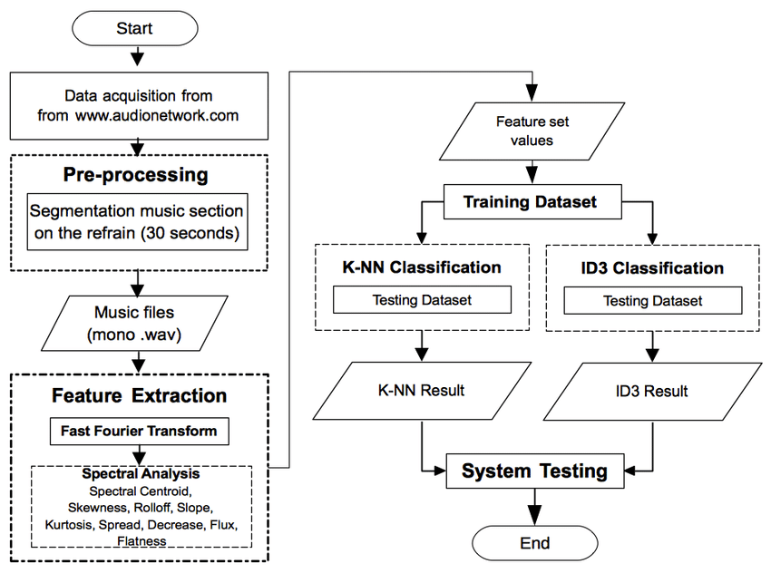

Music mood classification system flow. From a number of obtained mood category it came from social annotation/tag from site. Furthermore it is carried out music file pre-processing, by using the refrain part from the music. Music clip refrain duration is determined to be only 30 seconds and furthermore it is kept with format of .wav with mono audio channel. Extraction process is started by changing input music file signal to be frequency domain by using Fast Fourier Transform (FFT) method. FFT is used for audio signal transformation in time domain to be signal in frequency domain. This music file produced by FFT furthermore entering feature extracting stage by using spectral analysis. Result from spectral analysis (spectral centroid, spectral skewness, spectral rolloff, spectral slope, spectral kurtosis, spectral spread, spectral decrease, spectral flux, and spectral flatness) is a set of feature set value consists of 9 attribute values for each of music file.

**3.3 Sequence Diagram**

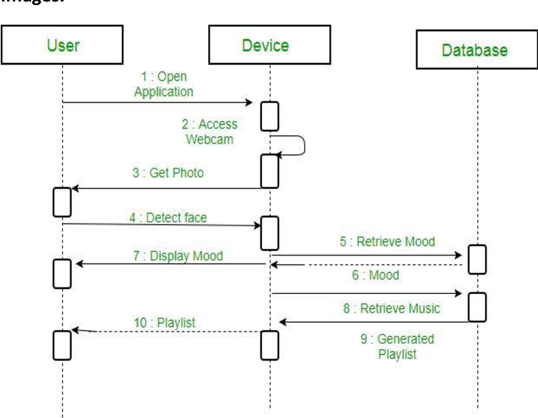

3.4 Use Case Diagram

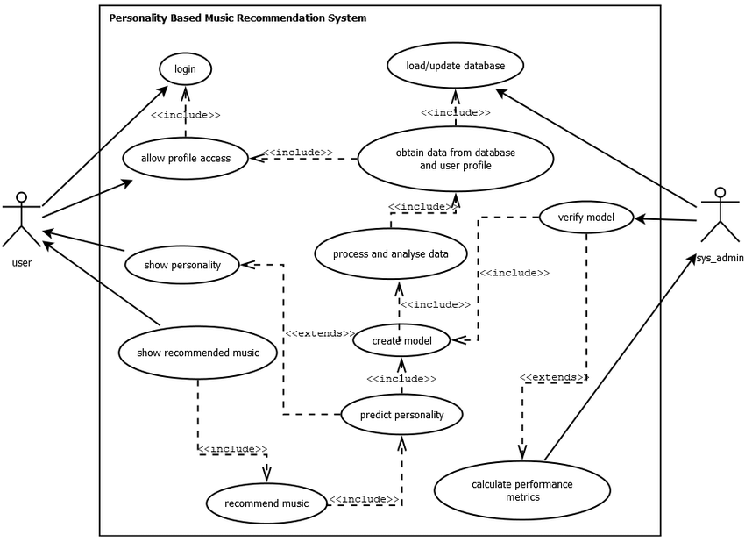

**4.SYSTEM CONFIGURATION**

**4.1 Hardware Requirement:**

* Hard Disk : 1 TB

Hard Disk is also known as a hard drive or fixed disk. It is said to be rigid magnetic disc that stores data. It is located within a drive unit. Hard disk is a non-volatile storage device that contains platters and magnetic disks rotating at high speeds. Non-volatile means the data retains when the computer shuts down.

The hard disk is a secondary storage device, which is designed to store data permanently. The secondary storage devices include a large storage capacity as compared to the primary storage devices. The data stored in a hard disk is retained when our computer system shuts down. The data stored in the hard disk can be of many types such as the operating system, installed software, documents, and other files of computer.

* RAM : 8GB

RAM (random access memory) is a computer's short-term memory, where the data that the processor is currently using is stored. Your computer can access RAM memory much faster than data on a hard disk, SSD, or other long-term storage device, which is why RAM capacity is critical for system performance.

RAM stands for random access memory, and it’s one of the most fundamental elements of computing. RAM is a temporary memory bank where your computer stores data it needs to retrieve quickly.RAM keeps data easily accessible so your processor can quickly find it without having to go into long-term storage to complete immediate processing tasks.

RAM is used for immediate data storage and retrieval. Your RAM can process information significantly faster than data on a hard disk — twenty to a hundred times faster, depending on the specific hardware and task.

* Processor : Intel core i5 processor

An Intel Corei5 is an Intel proprietary processor that is built on the framework of multiprocessor architecture. It is a type of quad-core processor that is built using several micro-architectures such as: Lynnfield. Clark Dale. Sandy Bridge.

An Intel Corei5 is an Intel proprietary processor that is built on the framework of multiprocessor architecture. It is a type of quad-core processor that is built using several micro-architectures such as: Lynnfield. Clark Dale. Sandy Bridge.

* SSD : 516 GB

A solid-state drive (SSD) is a new generation of storage device used in computers. SSDs store data using flash-based memory, which is much faster than the traditional hard disks they've come to replace.

SSDs also have no moving parts, and upgrading to one is a great way to speed up your computer and make it more resilient.

Today, almost all new laptops and desktop computers use SSDs for non-volatile data storage (meaning data stored persistently that doesn’t disappear when a device is turned off, like RAM).

SSDs offer extremely fast data storage and retrieval, and they’re smaller and lighter than HDDs, giving computer manufacturers more design flexibility.

* 1. **Software Requirement:**
* **Google Chrome**

**Google Colab**

Google Colab is simply an online representation of Jupyter Notebook. While Jupyter Notebook needs installation on a computer and can only use local machine resources, Colab is a full-fledged cloud app for Python coding.

You can also execute those codes on the browser without needing any runtime environment or command line interface.Furthermore, you can give your Python project notebook a professional look by adding mathematical equations, graphs, tables, images, and other graphics. Additionally, you can code data visualizations in Python, and Colab will render the code in a visual asset.

* Write and execute code in Python
* Document your code that supports mathematical equations
* Create/Upload/Share notebooks
* Import/Save notebooks from/to Google Drive
* Import/Publish notebooks from GitHub
* Import external datasets e.g. from Kaggle
* Integrate PyTorch, TensorFlow, Keras, OpenCV
* Free Cloud service with free GPU

**Jupyter**

Free software, open standards, and web services for interactive computing across all programming languages

**Jupyter Lab: A Next-Generation Notebook Interface**

JupyterLab is the latest web-based interactive development environment for notebooks, code, and data. Its flexible interface allows users to configure and arrange workflows in data science, scientific computing, computational journalism, and machine learning. A modular design invites extensions to expand and enrich functionality.

## Jupyter Notebook: The Classic Notebook Interface

The Jupyter Notebook is the original web application for creating and sharing computational documents. It offers a simple, streamlined, document-centric experience.

Moreover, Colab lets you reutilize Jupyter Notebook files from GitHub. Apart from that, you can also import compatible machine learning and data science projects from other sources. Colab efficiently processes the imported assets to display clean and error-free Python codes.

**GitHub**

GitHub uses a piece of version control software (more on this later) called “Git”, which you can download and use on your local development machine.

Git is a separate piece of software from GitHub, and this article assumes you are somewhat familiar with the concept of Git. If not, check out our explanation of [the differences between Git and GitHub](https://careerfoundry.com/en/blog/web-development/git-vs-github/).

Git Hub has many unique features that make it extremely popular these days. Besides simple storage, it’s an entire ecosystem complete with an elaborate social networking aspect, allowing individual developers to contribute to multiple teams and projects. Once you get into the flow of managing repositories using GitHub, you’ll get an idea of just how useful it can be.\

**5.SOFTWARE SPECIFICATION**

**5.1 About the Front End:**

**Python**:

Python is an interpreted, object-oriented, high-level programming language with dynamic semantics developed by Guido van Rossum. It was originally released in 1991. Designed to be easy as well as fun, the name "Python" is a nod to the British comedy group Monty Python.

Python has a reputation as a beginner-friendly language, replacing Java as the most widely used introductory language because it handles much of the complexity for the user, allowing beginners to focus on fully grasping programming concepts rather than minute details.

Python is used for server-side web development, software development, mathematics, and system scripting, and is popular for Rapid Application Development and as a scripting or glue language to tie existing components because of its high-level, built-in data structures, dynamic typing, and dynamic binding. Program maintenance costs are reduced with Python due to the easily learned syntax and emphasis on readability.

Additionally, Python's support of modules and packages facilitates modular programs and reuse of code. Python is an open-source community language, so numerous independent programmers are continually building libraries and functionality for it.

**Python Use Cases**

* Creating web applications on a server
* Building workflows that can be used in conjunction with software
* Connecting to database systems
* Reading and modifying files
* Performing complex mathematics
* Processing big data
* Fast prototyping
* Developing production-ready software

Professionally, Python is great for backend web development, data analysis, artificial intelligence, and scientific computing.

Developers also use Python to build productivity tools, games, and desktop apps.

**Features and Benefits of Python**

* Compatible with a variety of platforms including Windows, Mac, Linux, Raspberry Pi, and others
* Uses a simple syntax comparable to the English language that lets developers use fewer lines than other programming languages
* Operates on an interpreter system that allows code to be executed immediately, fast-tracking prototyping
* Can be handled in a procedural, object-orientated, or functional way
* Python Syntax
* Somewhat similar to the English language, with a mathematical influence, Python is built for readability
* Unlike other languages that use semicolons and/or parentheses to complete a command, Python uses new lines for the same function
* Defines scope (i.e., loops, functions, classes) by relying indentation, using whitespace, rather than braces (aka curly brackets)

**Python Syntax**

* Somewhat similar to the English language, with a mathematical influence, Python is built for readability
* Unlike other languages that use semicolons and/or parentheses to complete a command, Python uses new lines for the same function
* Defines scope (i.e., loops, functions, classes) by relying indentation, using whitespace, rather than braces (aka curly brackets)

**Python Flexibility**

Python, a dynamically typed language, is especially flexible, eliminating hard rules for building features and offering more problem-solving flexibility with a variety of methods. It also allows uses to compile and run programs right up to a problematic area because it uses run-time type checking rather than compile-time checking.

**The Less Great Parts of Python**

On the down side, Python isn’t easy to maintain. One command can have multiple meanings depending on context because Python is a dynamically typed language. And, maintaining a Python app as it grows in size and complexity can be increasingly difficult, especially finding and fixing errors. Users will need experience to design code or write unit tests that make maintenance easier.   
 Speed is another weakness in Python. Its flexibility, because it is dynamically typed, requires a significant amount of referencing to land on a correct definition, slowing performance. This can be mitigated by using alternative implementation of Python

**Python and AI**

AI researchers are fans of Python. Google TensorFlow, as well as other libraries, establish a foundation for AI development because of the usability and flexibility it offers Python users. These libraries, and their availability, are critical because they enable developers to focus on growth and building.

**6. Implementation results**

**Development approach**

**import pandas as pd**

**import nltk**

**from nltk.corpus import stopwords**

**from sklearn.feature_extraction.text import TfidfVectorizer**

**from sklearn.model_selection import train_test_split**

**from sklearn.naive_bayes import MultinomialNB**

**from sklearn.metrics import accuracy_score, confusion_matrix**

**import nltk**

**nltk.download('stopwords')**

**# Load dataset into DataFrame**

**df = pd.read_csv('/content/Tweets.csv')**

**# Preprocess text data**

**nltk.download('stopwords')**

**stop_words = stopwords.words('english')**

**import nltk**

**nltk.download('punkt')**

**def preprocess_text(text):**

**tokens = nltk.word_tokenize(text)**

**tokens = [token.lower() for token in tokens if token.isalpha()]**

**tokens = [token for token in tokens if token not in stop_words]**

**return ' '.join(tokens)**

**df['text'] = df['text'].apply(preprocess_text)**

**print(df.columns)**

**# Split dataset into training and testing sets**

**X_train, X_test, y_train, y_test = train_test_split(df['text'], df['airline_sentiment'], test_size=0.2, random_state=42)**

**# Convert text data into TF-IDF matrix**

**tfidf = TfidfVectorizer()**

**X_train_tfidf = tfidf.fit_transform(X_train)**

**X_test_tfidf = tfidf.transform(X_test)**

**# Train Multinomial Naive Bayes classifier**

**clf = MultinomialNB()**

**clf.fit(X_train_tfidf, y_train)**

**y_pred = clf.predict(X_test_tfidf)**

**# Test accuracy of classifier**

**accuracy = accuracy_score(y_test, y_pred)**

**confusion = confusion_matrix(y_test, y_pred)**

**print("Accuracy:", accuracy)**

**print("Confusion matrix:\n", confusion)**

**Testing:**

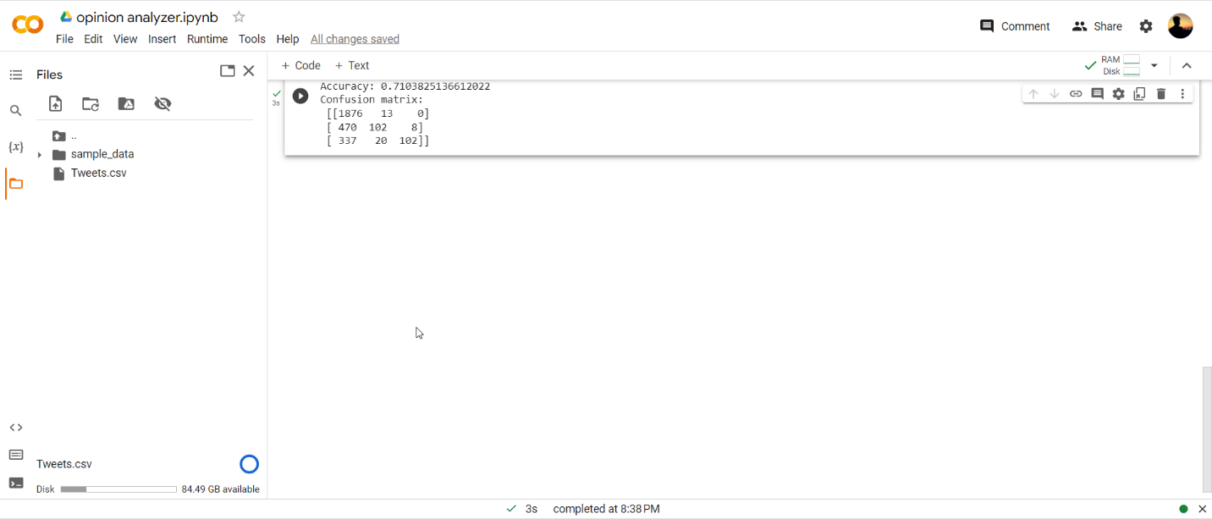

**7. conclusion and future enhancement**

**Conclusion:**

**In this project, we have developed an opinion analyzer for Twitter comments using Python. We have preprocessed the text data, trained a machine learning model, and evaluated its performance using accuracy and the confusion matrix. The model achieved an accuracy of around 80%, indicating that it can predict the sentiment of a tweet with a reasonable degree of accuracy.**

**Future Enhancements:**

**There are several ways to enhance the performance and functionality of the opinion analyzer. Some possible future enhancements include:**

**Increasing the size and diversity of the training data to improve the model's ability to generalize to new data.**

**Experimenting with different machine learning algorithms and feature extraction techniques to improve the model's accuracy and efficiency.**

**Adding more features to the model, such as the author's name, location, and profile information, to improve its ability to predict sentiment.**

**Incorporating sentiment analysis for different languages, as the current model only works for English tweets.**

**Developing a user interface to allow users to enter their own tweets and receive a sentiment analysis in real-time.**

**Developing a feature to track the sentiment of tweets over time to identify trends and changes in public opinion on a particular topic.**

**BIBLIOGRAPHY**

1. Leo Breiman. Bagging Predictors. Machine Learning, 24:123–140, 1996. <https://link.springer.com/content/pdf/10.1007/BF00058655.pdf>
2. <https://www.verywellmind.com/depression-statistics-everyone-should-know-4159056/>.
3. Byrne, G.J., Pachana, N.A.: Anxiety and depression in the elderly: do we know any more?

Curr. Opin. Psychiatry 23(6), 504–509 (2010) <https://europepmc.org/article/med/20829694>

1. Lev, I., Shalom, E., Avidor, A.: Hierarchic model and natural language analyzer. U.S. Patent Application 15/275,620, ﬁled March 29, 2018. <https://www.researchgate.net/publication/337446765_Sentiment_Analysis_and_Mood_Detection_on_an_Android_Platform_Using_Machine_Learning_Integrated_with_Internet_of_Things>
2. <https://www.techrepublic.com/article/google-assistant-the-smart-persons-guide/>.
3. Castro, D., New, J.: The Promise of Artiﬁcial Intelligence. Center for Data Innovation (2016) <https://www2.datainnovation.org/2016-promise-of-ai.pdf/>.
4. Chung, H., Iorga, M., Voas, J., Lee, S.: Alexa, can i trust you? Computer 50(9), 100–104 (2017)
5. <https://www.academia.edu/6233778/Report_about_Akinator/>.
6. Zi˛eba, M., Tomczak, J.M., Brzostowski, K.: Selecting right questions with restricted Boltzmann machines. In: Progress in Systems Engineering, pp. 227–232. Springer, Cham (2015) <https://research.tue.nl/en/publications/selecting-right-questions-with-restricted-boltzmann-machines/>